1. Go to SE80. Create a function group as per the steps given below.
   1. Select function group from the drop down list. Enter a function group name.

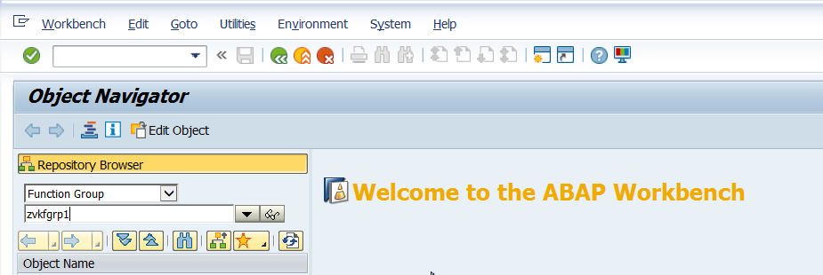

* 1. Press Enter. Press yes in the dialog box below.

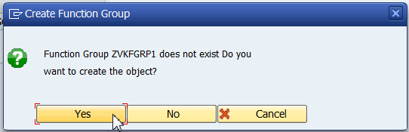

* 1. Save this.

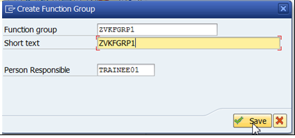

* 1. Save in a package/local object.
  2. Activate function group.

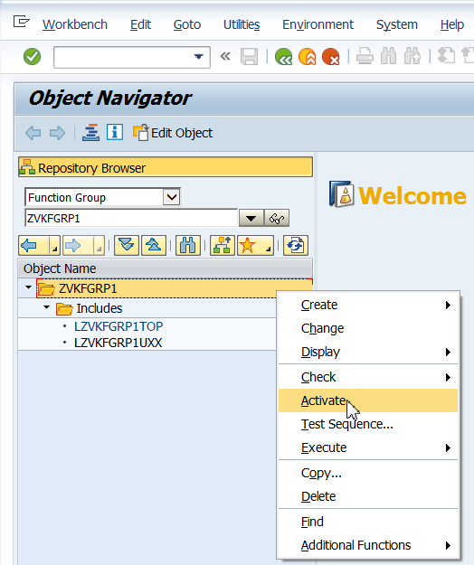

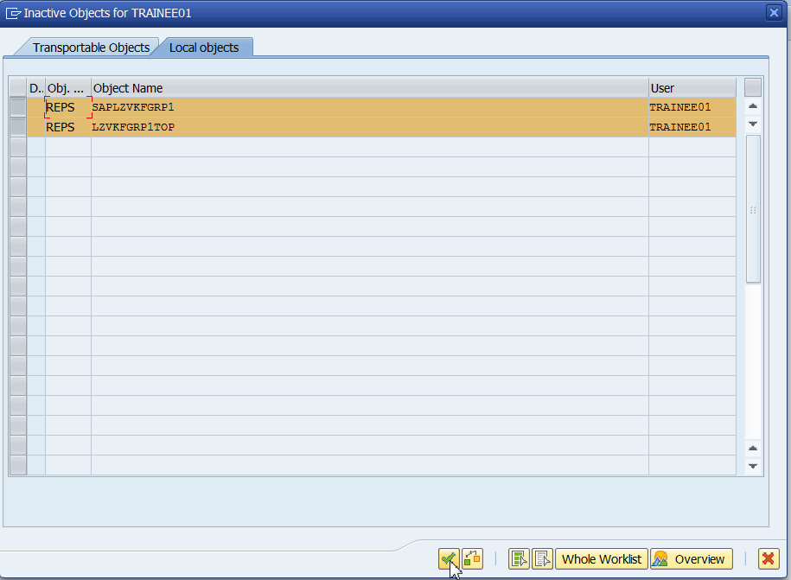

* 1. View the function group created.

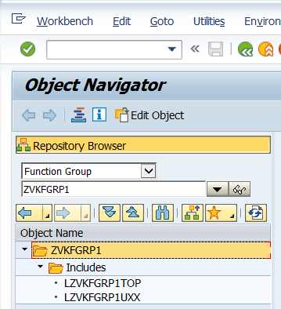

1. Go to SE11. Open an existing table in change mode.
2. Click on utilities->Table Maintenance Generator

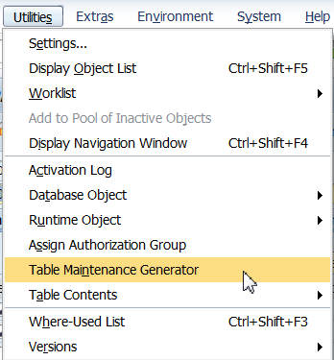

1. Select Authorization Group at &NC& i.e w/o auth. group. Enter the function group name as created in step 1. Press enter. Select Maintenance type as One Step.

Click on Find Screen Numbers.

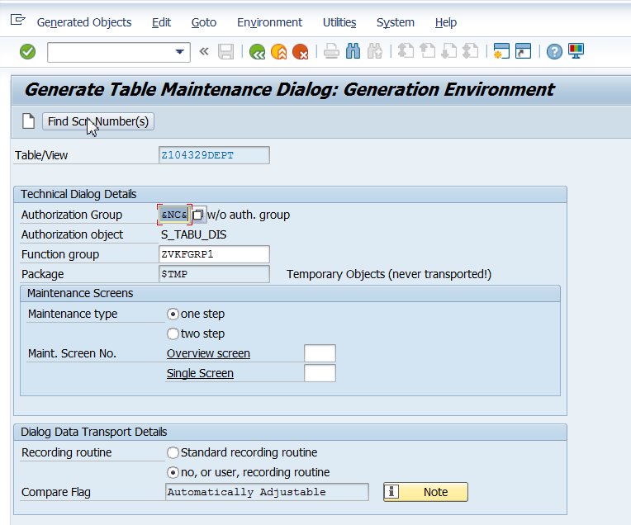

1. Select propose screen numbers. Click on continue.

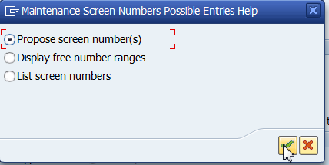

1. Click on create. Save it in package/local object.

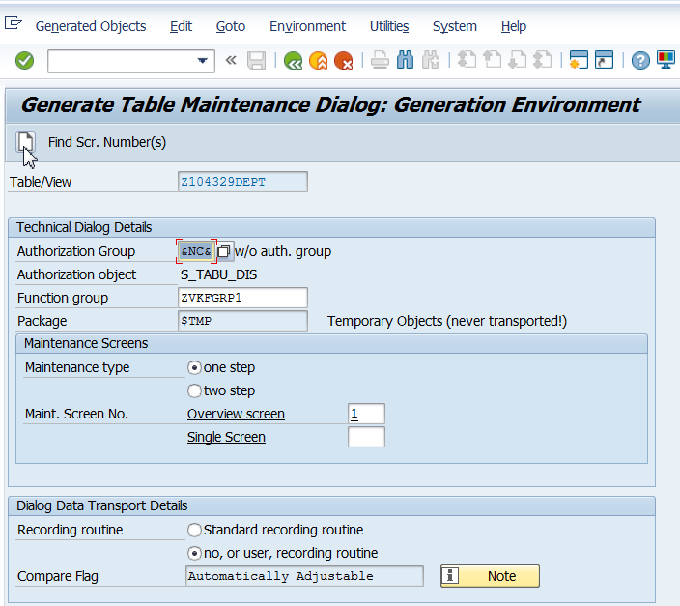

1. Observe the screen.

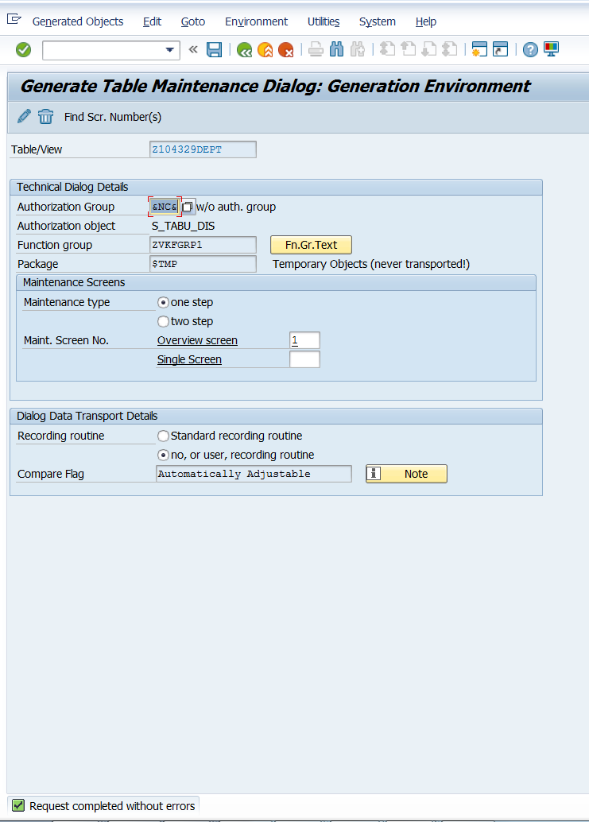

1. Go back. Create entries.

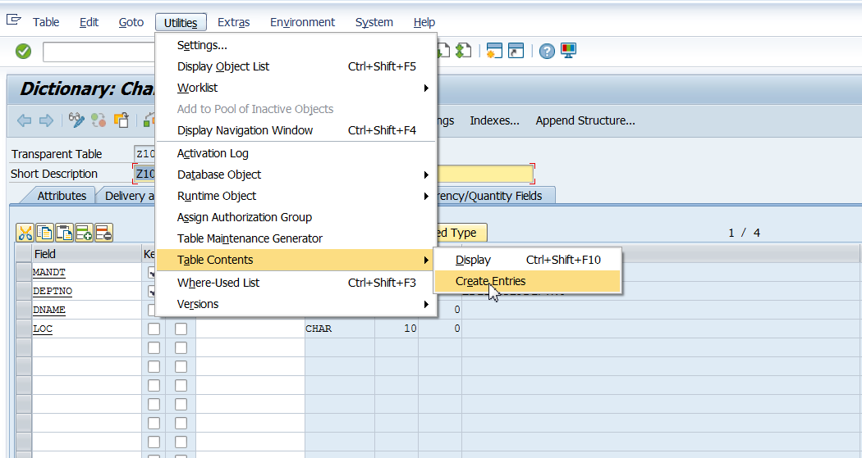

1. Click on New Entries. Existing records may be modified.

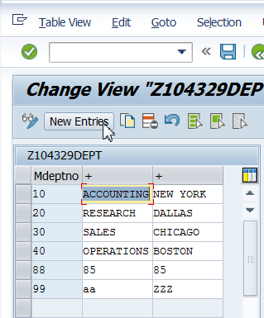

1. In SE80 you may see that relevant code for the TMG is put in the function group.

